**DIGITAL SIGNAL PROCESSING LAB EXPT.9**

**NIKHIL ROUT**

**22BEC1020**

**AIM:**

**➢ To design a Digital IIR Butterworth Low Pass Filter with Maximum Passband Loss = 2 dB, Minimum Stopband Loss = 35 dB, Passband Cut-Off Frequency = 1500 Hz, Stopband Cut-Off Frequency = 2000 Hz and Sampling Rate = 8000 Hz.**

**➢ To design a Digital IIR Chebyshev - I Low Pass Filter with Maximum Passband Loss = 2 dB, Minimum Stopband Loss = 35 dB, Passband Cut-Off Frequency = 1500 Hz, Stopband Cut-Off Frequency = 2000 Hz and Sampling Rate = 8000 Hz.**

**➢ To design a Digital IIR Chebyshev - II Low Pass Filter with Maximum Passband Loss = 2 dB, Minimum Stopband Loss = 35 dB, Passband Cut-Off Frequency = 1500 Hz, Stopband Cut-Off Frequency = 2000 Hz and Sampling Rate = 8000 Hz.**

**➢ To design a Digital FIR Hamming – Windowed High Pass Filter with Passband Cut-Off Frequency = 2500 Hz and Sampling Rate = 8000 Hz.**

**LOW PASS IIR FILTER - BUTTERWORTH**

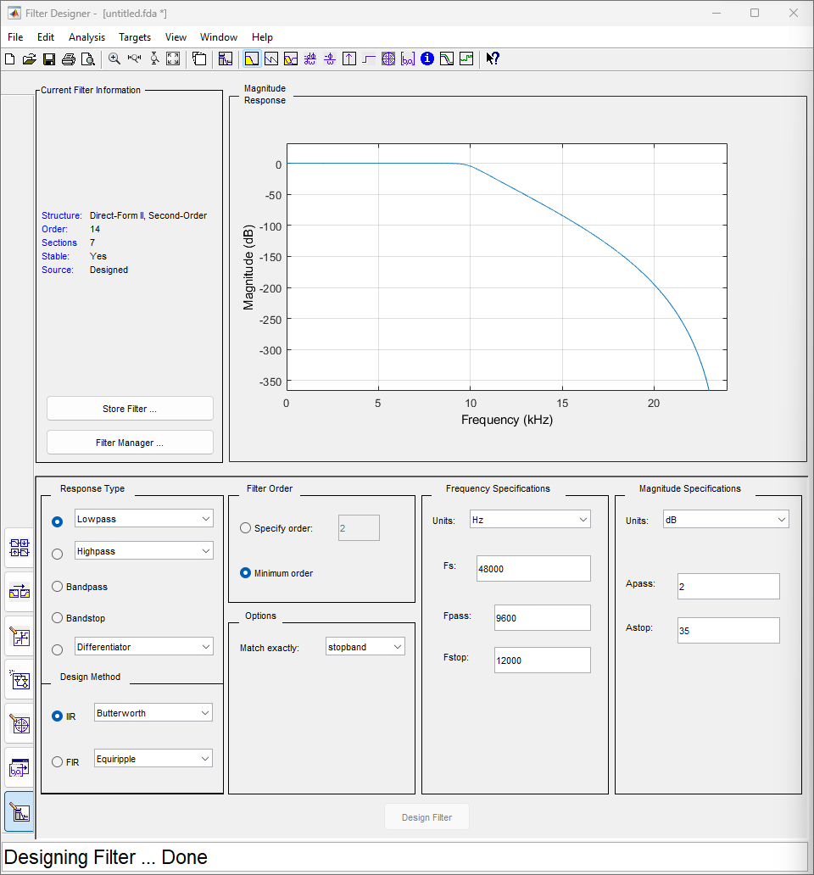

**ORDER-1**

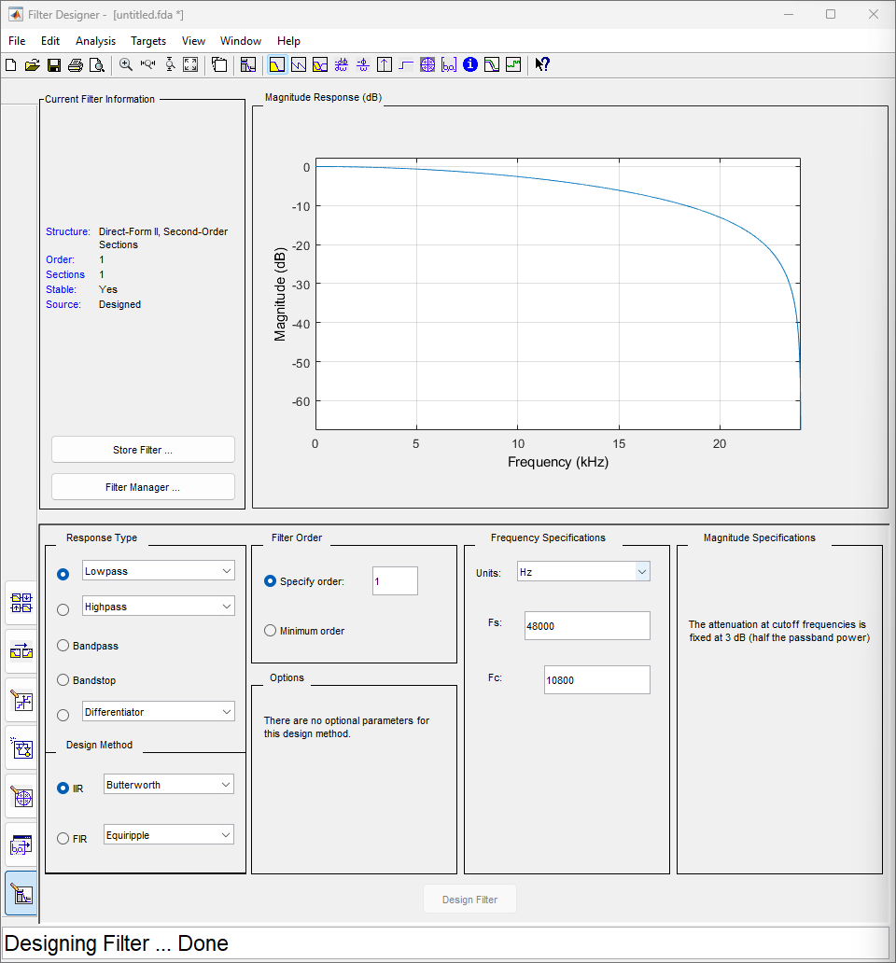

**ORDER-3**

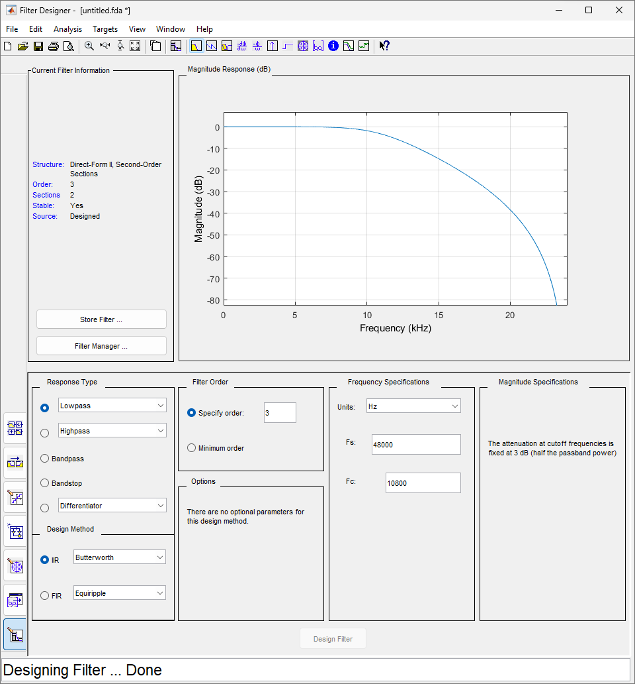

**ORDER-100**

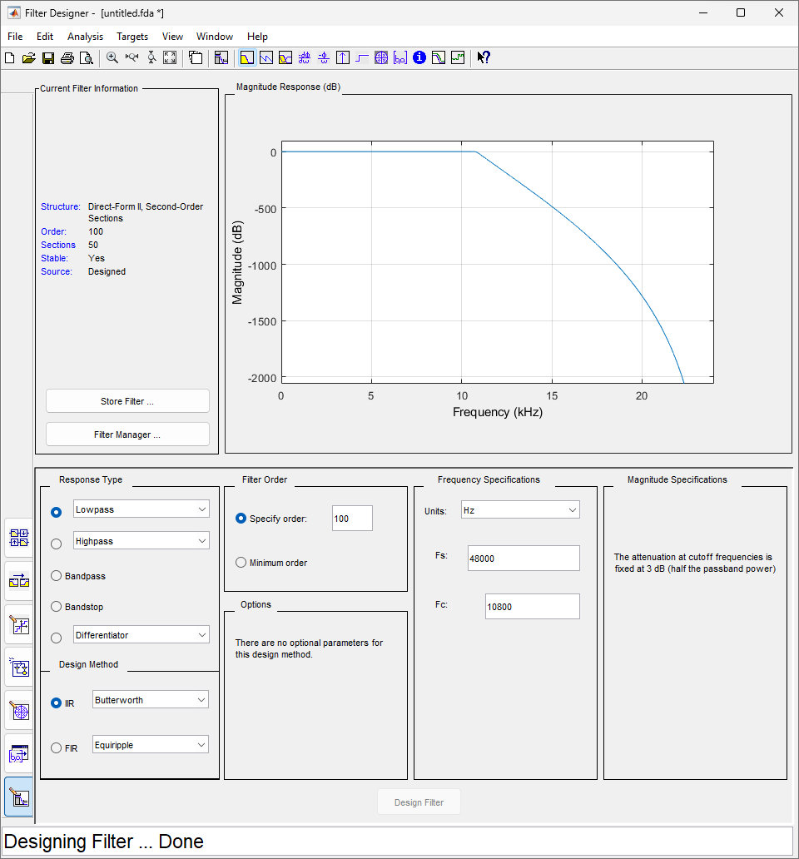

**LOW PASS IIR FILTER – CHEBY1**

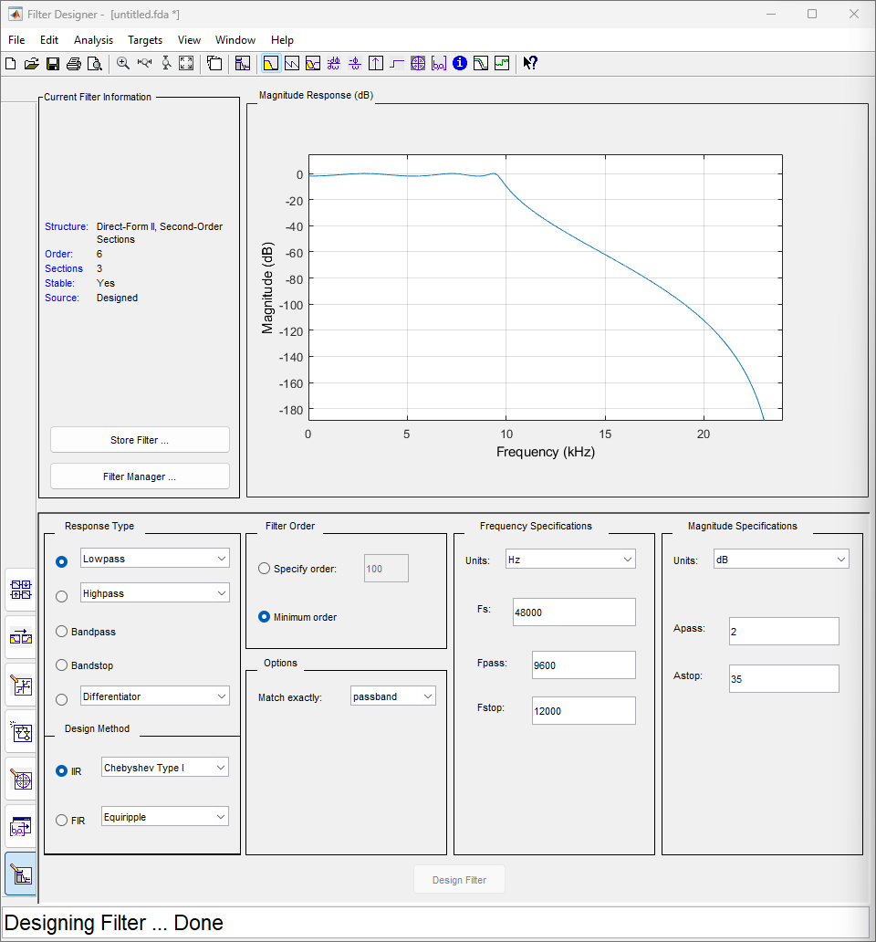

**LOW PASS IIR FILTER – CHEBY2**

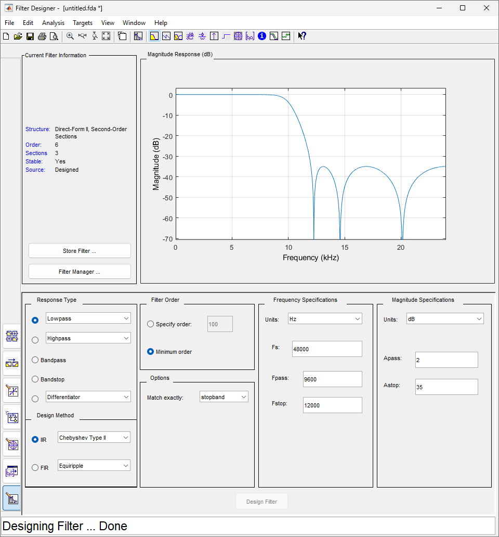

**HIGH PASS FIR FILTER – WINDOW HAMMING**

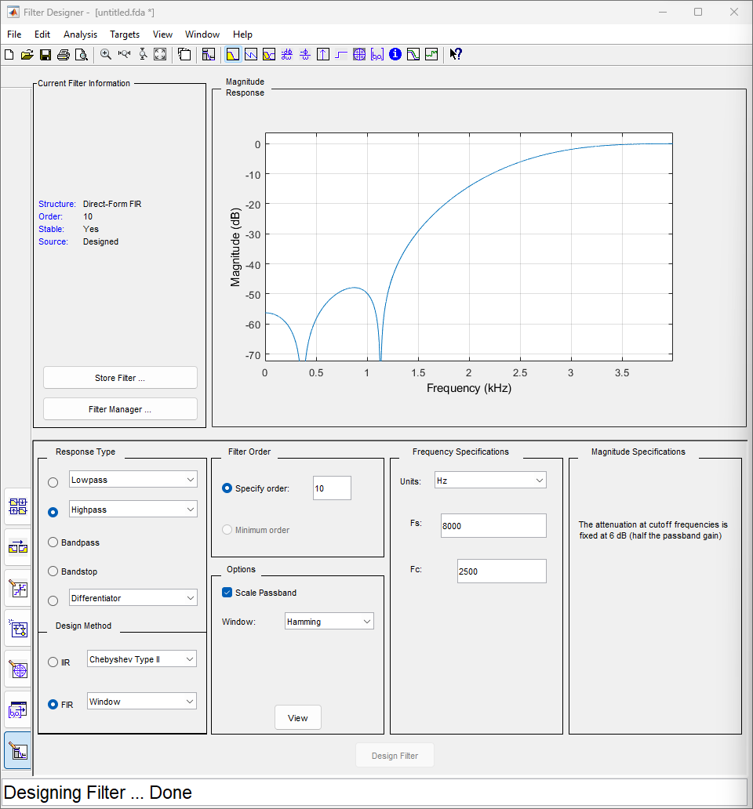

**POLE-ZERO PLOT**

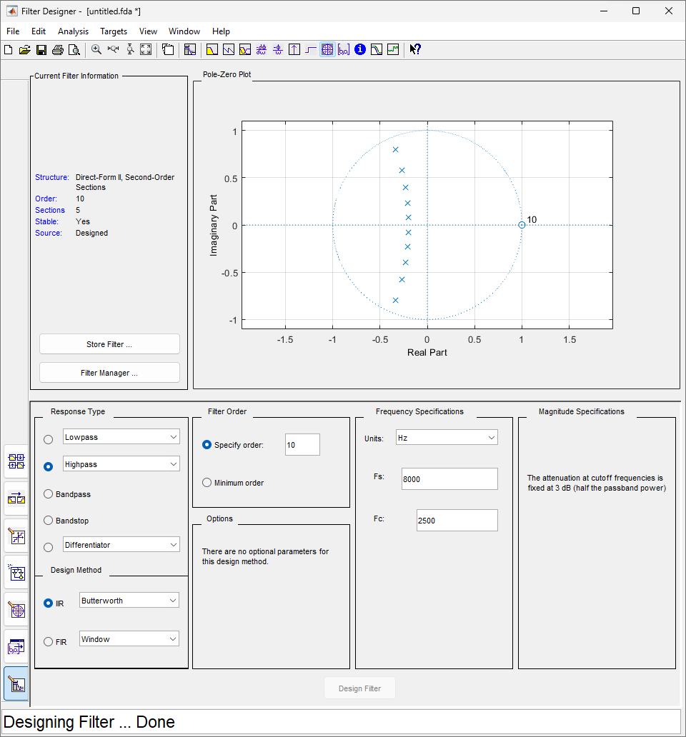

**FILTER-COEFFICIENTS**

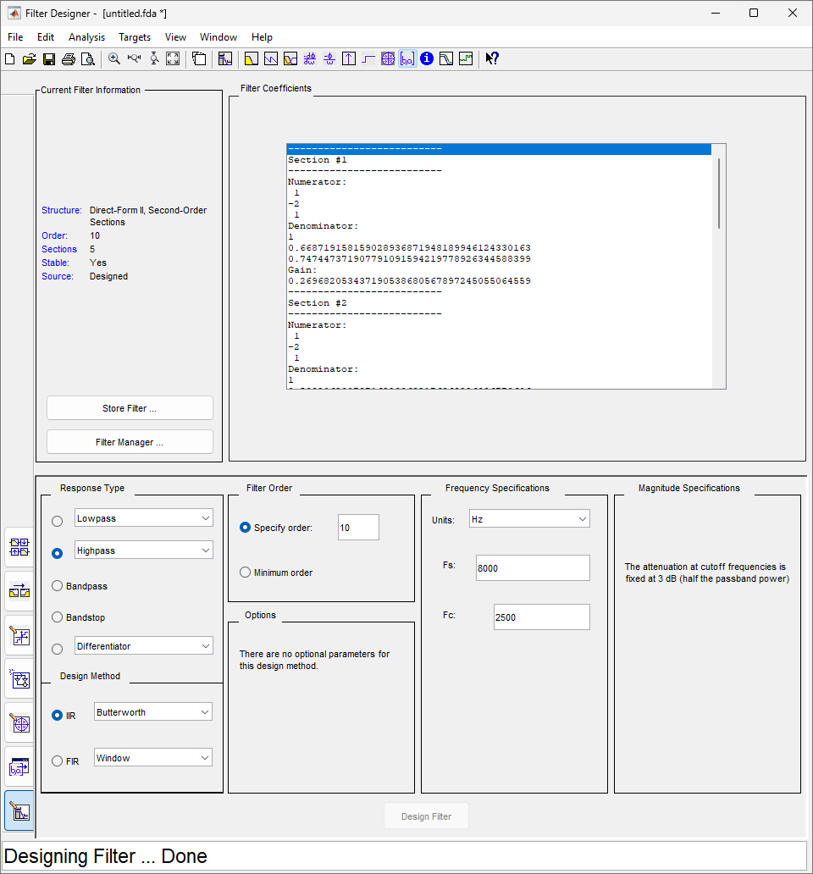

**BANDPASS BUTERWORTH FILTER**

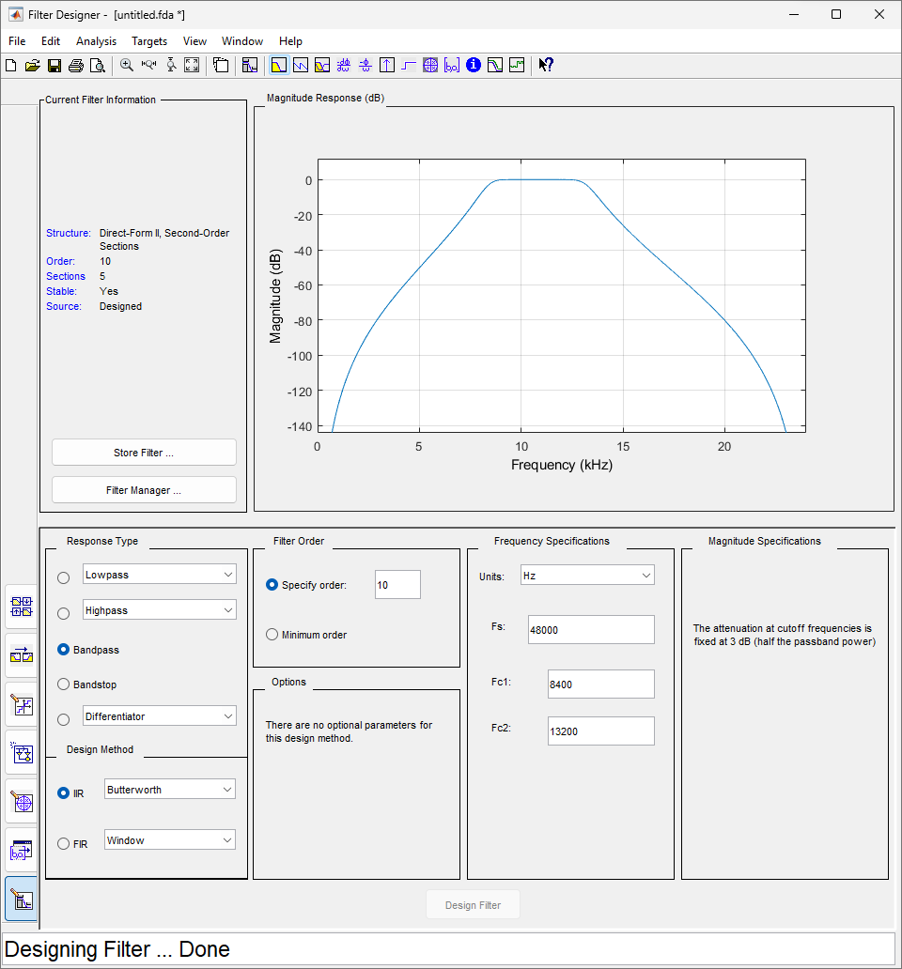

**BANDSTOP BUTTERWORTH IIR FILTER**

